# Introduction

As use of digital tools has spread over many aspects of everyday life, environmental infrastructure has employed these tools too. One type of these digital tools revolves around use and collection of geographical information among the various actors including public, citizens or non-experts (Bubalo et al., 2019).

This type, called generally as participatory mapping (PM) (Brown et al., 2018), consists of citizen science (CS), volunteered geographic information (VGI), public participatory GIS (PPGIS), and smart cities initiatives where often public/citizens/non-experts are source of spatial data-collection. In other words, these tools enable kind of crowdsourcing or collaboration in making geographic information (Bubalo et al., 2019). The aim of data-collection which corresponds with type of participation and highly varies in each of the initiatives, can range from being a mere hobby, conservation of natural resources, involvement in scientific projects, to reporting issues, decision-making and urban planning.

From a scientific point of view, the data created from PM, is sometimes criticized as being not reliable (Brown, 2017). On the other hand, others question the distinction between expert and non-expert and argue that most of the time people involved in PM are already concerned citizens which are anyhow expert in their own field (Landström, 2019).

When these initiatives are designed by public authorities and agencies for engaging citizens, often issues of diversity are discussed. Scholars argue that not necessarily the data-collected for a planning and decision-making initiative can be considered as data from all groups of community. Rather, the information is affected by digital divide and socioeconomic character of participants (Landström, 2019).

Considering the criticism toward PM tools, the idea in this paper is despite common technical characteristic of these tools, they can be only investigated in their particular context. Thus, in this report firstly an exploratory search is conducted on use of PM tools in environmental infrastructures to review varieties and various actors. Then, the technical aspects of these tools are briefly discussed, and two selected case studies is investigated among them. Finally, the discussion is on some of the undermined aspects of PPGIS/PGIS tools.

# Research Methods

This paper is part of my PhD project on environmental infrastructures which investigates how various actors interact with each other using digital tools.   
This paper is primarily focused on an exploratory literature review to investigate use of digital tools (PGIS, PPGIS, VGI and citizen science) in environmental participation.

Initially, keywords of PGIS, PPGIS, VGI and citizen science were searched through two databases of web of science and Scopus. The results were of 50 most cited studies were then screened. Many of them did not involve technical aspects and were removed from this exploratory review. Next, in close reading of the texts, other references and tools (especially in GIThub) were found and traced. And finally among found results, two case studies are investigated

# The participatory spatial tools in VGI, PPGIS and citizen science: various actors

MP tools were initially used in planning. However, now they are widely used in citizen science projects, smart cities application, customer relationship management and environmental management (Haklay et al., 2002). Broadening of their scope has led to involvement of citizens, public agencies, science and corporation actors.

# Technical aspects of PM: some examples

Although highly variable in design and implementation), a simplified technical mechanism of PM tools enables adding vector layers on map base layers. In other words, participants are asked to identify locations on a map based application programming interface (API) (Rall et al., 2019). The technical mechanism of PM tools is argued to have been facilitated by advent of web 2.0 for online mapping (Bubalo et al., 2019).

Despite the commercialisation of the tools, there exist an active community in Github which provide open-source scripts on VGI and PGIS for mapping spatial data from social medias, conveying VGI information from website to baselayers, etc[1].

In another study on PPGIS application in bikeability by Ali (2021), typical WebGIS Model is illustrated.

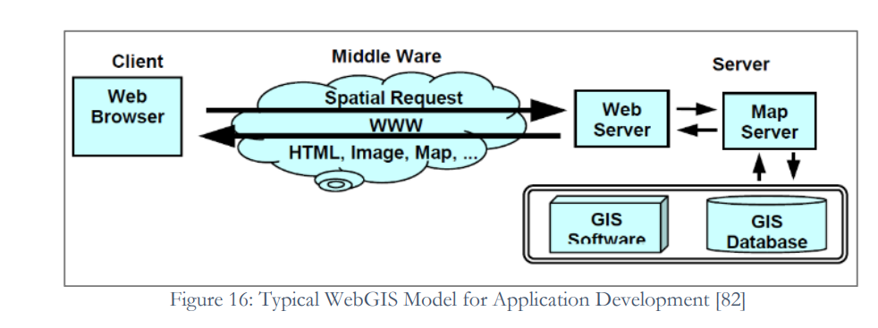

Figure 1 Typical WebGIS model

Regarding data-collection, how geographical information is added and collected can range from very passive form (in case of Twitter, flicker, and cyclist data) to very engaged (in cases of showing preferences, problem-solving and co-planning. Here we go through some examples of various type of data-collection.

## Showing preferences by self-report, adding pictures and selecting between options

An example of this is reflected in Brown’s and others’ article where they employ PM to convey information about land use and zoning to citizens (Brown et al., 2018). In their project hey have designed an internet based PGIS survey as a public participation tool which uses Google maps API. Participants drag and drop icons representatives of land use and preferences into a map in form of URL website.

There are many other cases such as Mappines, EmoMap, GreenMapper, Greenttracker, My DynamicForest and MyPlace with similar mechanism where participants add their preferences (by adding icons and points to map), add pictures or self-reports (Bubalo et al, 2019) (Korpilo et al., 2018). Another example which is initiated by an NGO is Wheelmap in Germany where an online map is developed to show accessible places.

Most of these initiatives use OSM and other open base map layers inbuilt in their website or application.

## Passive data collection or citizen sensory

In this kind of initiatives, data is collected passively and through other mediators rather than users’ input. The mediators can be a sensor kit or an API which has been collected data such as flicker and cycling routs API.

MacArthur and Hong (2019), investigate a PGIS project for visualizing cyclists travel paths using crowdsourced data. The graph below is how they summarized their method and data.

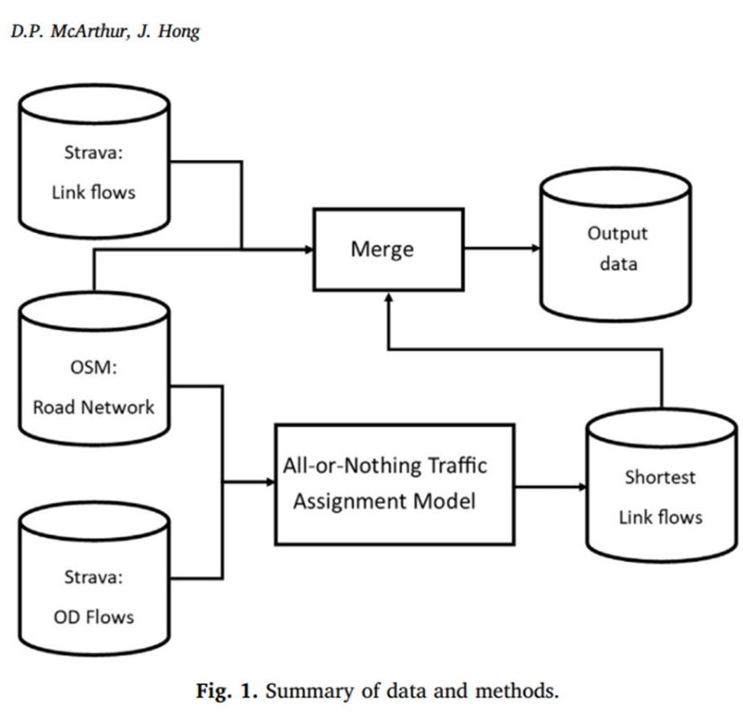

Here Strava is a commercial application which gives cyclist route data for free. However, there are many open-source code for acquiring this data such as AequilibraE[2].

In other projects called WeSense and ISPEX, sensor gadgets are attached to mobile phone which work along with the mobile applications and by using GPS data, geographic information of pollution and river flows are sent for visualization and aggregation (McCrory et al., 2017) (Lanfranchi et al., 2014). Or in case of Pimi airbox in Beijing, airpollution kits are provided for crowdsensing.

In these tools, participation happens in a very passive form unless there are other community activities along them.

## Co-planning and simulation platforms

These tools are technically more complicated. Famous Map making websites such as google map, Wikimapia and Openstreetmap (OSM) can be considered as part of this category.

An example of simulation platform is MSP Challenge. MSP challenge is an open source initiative founded by Breda University of Applied science in the Netherlands. It includes two parts of MSP challenge board game and MSP challenge simulation platform and VR. However, most of the time their users require prior knowledge on how to use the maps and their interfaces are not customized for environmental participation. One other aspect is that there is no direct link between MSP challenge simulation platform and general public. In some of their project groups of publics are involved and in other not. This is because the high level of complexity in using such as platform.

Platform vision for future is not to be contained in the university, but rather continue to exist outside too. However, the path of making the platform open source is risky. Since fundings are required for technical maintenance and development. Most of the times, platforms are outdated if not maintained due to rapid changes in software. As a result, most of the money from new projects are spent on maintenance and updates and the development is an ongoing process.

# Monetizing PM: from open-source to platformisation

As mentioned before, many components of PGIS are open source from baselayers to code scripts which operationalise PM. For example, google map provide a service where users add layers to map and download the data themselves Or most of the projects reviewed in PGIS/PM are using OSM and google maps as their baselayers.

However, on one hand due to costs of maintenance, many of the projects initiated by universities, NGO or other parties fade away as the project funding finishes. This was apparent during exploratory search where some of the links in articles and some of the famous projects such as ISPEX no longer were active. Other ways to stay alive and continue for these projects are to assetise their data or their software/codes.

On the hand, many public agencies, science institutions and other bodies are interested in making their own participatory mapping services, but they cannot possibly develop the web-based PGIS or mobile applications for this aim although some source code are still open in Github and other libraries.

As a result, private companies have been formed to provide PGIS services to various actors which are customizable. In some cases, these companies are transformations of initially university projects or participatory action research group activism.

Among them, famous international companies are Maptionnaire, CitizenLab, Spotteron, Civocracy and Hive which have mostly governmental, NGO and private customers. These companies charge their customers by monthly subscriptions.

The provision of application and software by private companies which offer some part of services previously offered by governmental infrastructures is called the process of platformisation by Van Dijk and others (Van Dijck et al., 2019).

# Investigation of some case studies

In this part two prominent cases studies are investigated closely by interviews, materials and videos on their websites.

## ObstacEELS

*ObstacEELS*  is a “citizen science initiative led by Zoological Society of London (ZSL) which has been collaboratively developed with four River Trusts and Thames Estuary Partnership as a part of environmental project “Thames Catchment Community Eels Project”[3]. The project was inspired by fish migration [road map](https://fishroadmap.london/) and it was at the planning stage when applied for UK National Lottery Funding and received Green Recovery Challenge funding.

In *ObstacEELS,* near each of the five rivers*[4],* volunteers go in group for river walks and take photo and collect data of the barriers of fish passages (eel migration). In their website, in each of the project one can see a mixture of spatial data visualizations and photos of creative group activities to remove the barriers or assess the pollutions by volunteers which make the project unique. At the time when the project was initiated, people felt the need to socialize as it was during covid pandemic. Thus, initiators of the project framed rivers walk and data collection as a kind of social activity and from a social health perspective too.

At the moment, the project has 97 volunteers and majority of volunteers are joined after advertisement in social medias. Of course, there were also some volunteers from others river trust projects.

The data in *ObstacEELS* platform comes from various sources which includes GIS layers, formal data and citizen scientist collected data. Citizen scientists are trained to report, share and store data. The input from citizen scientists, after being deduplicated and cleaned by *Obstaceels* team, are uploaded in the platform. Thus, the data needs to go through developers. In addition, app developers get regular feedbacks from users and thus the app gets updated on the goals.

The existing formal datasets underestimate the barriers of fish passages in the rivers. Interestingly, citizen scientist by going into the place, update and correct that data. The data from citizen scientists show 50% more barriers than the formal datasets*.*

*ObstaEELS* involves various stakeholder from Rivers trusts and organizations. In each of the rivers, *ObstacEELS* has made a vision map which inform policy-makers and decision-making bodies. One of the drives of this project is WDF which brings the different organizations together.

*ObstacEELS* app is developed by [*Natural Aptitude*](https://www.natural-apptitude.co.uk/). The app is mostly used by volunteers as a communication tool. But to use the app, one does not need to be IT skilled, and the app is very user friendly. Regarding the maintenance they have faced difficulties and one of the reasons they recommend all group members to collect data is that the data would not get lost during glitches*.*

One of the big advantages of this project is that it is built on the existing active organizations. The project itself comes from collaborations of organizations and has made active ties with local actors. Other point about this project is that citizen science is a very crucial part of it and data collection for its volunteers occurs in a collective way. Their plan for future is to get sustainable and get more funding in order for the project to expand and continue. In other words, the project can not be sustained without work of its core members who have already spent lots of their time in networking and getting funds.

Another important aspect is how social context such as existing NGOs in the area and COVID pandemic has affected the success of this tools which is often undermined in PM projects.

## Drinkable Rivers

# Drinkable Rivers

[*Drinkable Rivers*](https://drinkablerivers.org/) is a participatory mapping/citizen science initiative based in the Netherland, established in 2020 which mixes using of gadget, community buildings and uploading VGI. The idea behind this project is that “drinkable river” should be a criterion for well-being of an environment. This project involves various integral activities including river walks and action communities, measurements with toolkits and citizen science digital platform.

First, the idea of river walk was initiated by Li An Phoa the founder of *Drinkable Rivers* project while she was in Canada. During river walks, she met other users, polluters, and inhabitants around the river while she started taking measurements. This experience became a basis to establish *Drinkable Rivers* *project* where through community building and making networks, individuals are trained and given toolkits to take measurements of pollution in each hub.

Thus, each hub -which can be initiated by individuals or organizations- has different strategies to make citizens engage and invite them. In each of the hub, *Drinkable Rivers* team train initiators of the hub and provide them with manuals and measurement kits. Then, the activities start and while having river walks along the rivers, citizens collect measurements and then upload their data of the river. The toolkits are made by the company *Earth Echo*.

The platform of *Drinkable Rivers* is developed by [*Nucleoo*](https://nucleoo.com/crafting-a-mission-driven-data-solution-with-dutch-ngo-drinkable-rivers/) which is a private company. The collected data can be visualized by *Drinkable Rivers* data platform. It is up to hubs how they want to proceed with the data collected or how they want to be in touch with policy makers.

One of the advantages of this platform is its focus on community building. The project builds network on various levels. For example, *Drinkable Rivers* team has initiated “networks of Mayors”. The emphasis on river walks and community building makes taking measurements a social activity. Other advantage is using the idea of “drinkable river”. This idea is very tangible for citizens and yet measurable. Many citizens might remember the rivers being drinkable in the past or have experienced drinking from a river. As a result, the idea of drinkable river is motivating and is a perfect goal to move toward to. The data gathered is compared with European water Directive Framework (WDF). The idea is to use this WDF for the stakeholders to take actions.

Regarding technical maintenance, there is no need for new hubs to develop or make adjustments of the platforms. Like other initiatives, they also had technical difficulties and they are transferring their data to new data platform. The project is progressing and now it is at the stage of developing hubs. But has plans of communicating with stakeholders to create hubs and inviting researchers to conduct research.

*Drinakable Rivers* too is centered on the idea of community making as an integral part of PM. Another advantage of this project is core members of the team recruit volunteers who are actually affected by pollution and live and work along the river. This makes the participation less “invited” (Landström, 2019) and leads to more concerned people to be involved (Suman et al., 2023)

# Discussions on Findings and case studies

The first aspect in reviewing digital tools in PM and the case studies are their actual usefulness in enabling environmental participation. As scholars have mentioned, there are recruiting challenges that these tools face and often forgotten(Bubalo, 2019). Reviewing case studies and examples point to the important of community building such as in Drinkable Rivers and Obstaceels along the use of PM tools if the projects are actually aiming to enable environmental participation and be sustained. Moreover, except for the well-known participatory tools of OSM, Wikimapia and Google maps, these tools are often transient. Lack of persistence due to insufficient or limited funding, technical maintenance and enough contribution, hurts environmental participation which is a long-term process rather than a quick and project based one.

In their article, Sörlin and wormbs (2018) discuss what they call as environing technologies. In their view, these technologies have political consequences and alter human perceptions about agency and environment. They argue that environing technologies can bring matters into existence or marginalise other matters. Using their framework and in case of environmental participation, PM tools are employed for many purposes such as natural hazard mitigation, conservation projects, and government-citizen relationship management but they were initially created for planning and as a continuation of community planning (Haklay, 2002). By now, there are major international companies which provide customizable PM services such as Maptionnaire, Spotteron and CitizenLab. Although these tools are valuable in gathering information from users and saving their time and energy, they frame participation in a very specific individual way. Most importantly, most PM tools do not require collective planning which was one of the central ideas of community mapping and social participation. Instead of being part of a community, participants which are now called users can be alone and, in their homes, while contributing to PM. Secondly, participation in PM tools translate participation into data and GIS layers through scripts and packages which are not necessarily accessible for the non-expert participants. Thus, participation which could be a mean to transparency of procedures becomes hidden and coded. As a result, participatory tools, provide a new definition of participation which is not collective but rather individualized and black-boxed. This new participation is also criticized in the literature as Not in My Back Yard which suggest a kind of individual rather than collective point of view (brown et al 2018 ).

Another aspect of use of digital tool in environmental participation is translation of local/participants’ knowledge into digitalised visualisation/analyse within digital “community”. Although the translation of local knowledge can be considered somehow facilitated by sharing stories, media and other formats, the idea that non-digital communities can be replaced by digital communities is also a form a reductionism. In this idea, with the promises of facilitation, efficiency and cost-reduction, non-digital groups of facilitators, groups and communities are not funded adequately and become marginal. However, as we have seen in case studies, one of the most successful cases in citizen science (drinkable rivers and Obstaceels) are the ones which are centred around community building in real life.

The last aspect to be emphasised in PM tools are introduction of new roles and sociality (Bowker, 2002). In using PM tools for government agencies and NGOs, computer scientists and private PM companies are now involved. In other words, although geographers are familiar with these digital tools and many sources are open. In order for an NGO to use of these open source scripts or software, new specialities are needed. Thus, outsourcing can be a good idea where previously was outsourced to social facilitators, social scientists, or planners.

# References

* Ali, H., 2021. Web-based PPGIS application for participatory spatial planning in context of bikeability (Doctoral dissertation).
* Bowker, G.C., Baker, K., Millerand, F. and Ribes, D., 2010. Toward information infrastructure studies: Ways of knowing in a networked environment. International handbook of internet research, pp.97-117.
* Brown, G., 2017. A review of sampling effects and response bias in internet participatory mapping (PPGIS/PGIS/VGI). Transactions in GIS, 21(1), pp.39-56.
* Brown, G., Sanders, S. and Reed, P., 2018. Using public participatory mapping to inform general land use planning and zoning. Landscape and Urban Planning, 177, pp.64-74.
* Bubalo, M., van Zanten, B.T. and Verburg, P.H., 2019. Crowdsourcing geo-information on landscape perceptions and preferences: A review. *Landscape and urban planning*, *184*, pp.101-111.
* Haklay, M. and Tobón, C., 2002. Usability Engineering and PPGIS-Towards a Learning-improving Cycle.
* Korpilo, S., Virtanen, T., Saukkonen, T. and Lehvävirta, S., 2018. More than A to B: Understanding and managing visitor spatial behaviour in urban forests using public participation GIS. Journal of Environmental Management, 207, pp.124-133.
* Landström, C., 2019. Environmental participation: Practices engaging the public with science and governance. Springer Nature.
* Lanfranchi, V., Wrigley, S.N., Ireson, N., Wehn, U. and Ciravegna, F., 2014, January. Citizens' observatories for situation awareness in flooding. In ISCRAM 2014 Conference Proceedings-11th International Conference on Information Systems for Crisis Response and Management (pp. 145-154). Sheffield.
* McArthur, D.P. and Hong, J., 2019. Visualising where commuting cyclists travel using crowdsourced data. Journal of transport geography, 74, pp.233-241.’
* McCrory, G., Veeckman, C. and Claeys, L., 2017. Citizen science is in the air–Engagement mechanisms from technology-mediated citizen science projects addressing air pollution. In Internet Science: 4th International Conference, INSCI 2017, Thessaloniki, Greece, November 22-24, 2017, Proceedings 4 (pp. 28-38). Springer International Publishing.
* Suman, A.B., Balestrini, M., Haklay, M. and Schade, S., 2023. When Concerned People Produce Environmental Information: A Need to Re-Think Existing Legal Frameworks and Governance Models?. *Citizen Science: Theory and Practice*, *8*(1).
* Rall, E., Hansen, R. and Pauleit, S., 2019. The added value of public participation GIS (PPGIS) for urban green infrastructure planning. Urban Forestry & Urban Greening, 40, pp.264-274.

1. <https://github.com/mocnik-science/osm-python-tools>

   <https://github.com/gboeing/osmnx>

   <https://github.com/topics/vgi>
2. https://github.com/AequilibraE/aequilibrae
3. https://www.thamesriverstrust.org.uk/thames-catchment-community-eels-project/obstaceels/
4. the Rivers Mole, Pang, Upper Brent, Ravensbourne and Middle and Lower Kennet